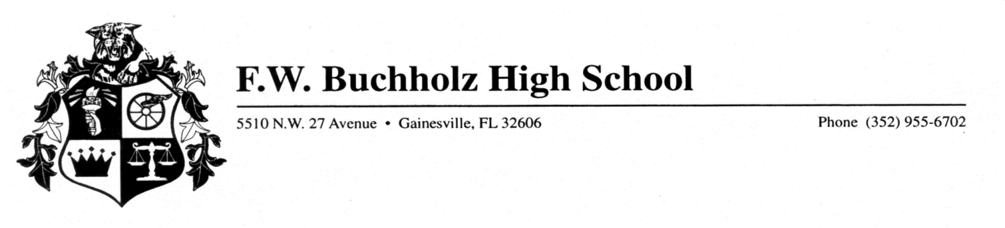
The Buchholz High School Cross Country Team will be hosting their 18th annual Bobcat Classic Cross Country Meet (5k) held October 6, 2018 at Santa Fe Community College. The meet is a long-time tradition for the Bobcats and is attended by all area local schools as well as teams from around the state as the meet is also the site for the class 4A and 1A region meets. We are looking for sponsorships from local business partners, families or community organizations to partner with us to make this meet a huge success.
Below are two ways you can sponsor the event with a tax deductible donation.
Boys Race Sponsor – $500 – your name will be announced at the beginning of each boys race and during awards, you can provide us with a sign to display at the meet and your logo or name will print on the meet t-shirts. **
Girls Race Sponsor - $500 – your name will be announced at the beginning of each girls race and during awards, you can provide us with a sign to display at the meet and your logo or name will print on the meet t-shirts. **
T-Shirt Sponsor - $200 – your logo or name will print on the meet t-shirts. **
If you are able to support this event and support the BHS Cross Country Team we thank you!!
Any questions or to be a sponsor please contact:
Alisa Mountain 352-598-0522 or alisa.mountain@gmail.com
*Please make checks payable to Buchholz Cross Country Boosters.
**We will provide any sponsors with a meet T-shirt if they would like one.

